**Light Experiments Booklet**

Group Members:

__________________________

__________________________

__________________________

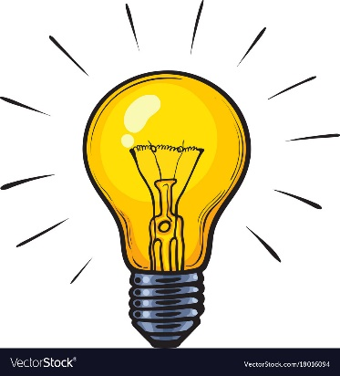

|  |  |
| --- | --- |
|  | Demonstrating the Law of Reflection in a Plane Mirror |
|  | Finding the Focal Length of Curved Mirrors |
|  | Forming Images with Curved Mirrors |
|  | Investigating Refraction |
|  | Investigating Depth Illusions |
|  | Finding the Critical Angle of a Perspex Block |
|  | Finding the Focal Length of Lenses |
|  | Investigating Images formed with a Convex Lens |
|  | Dispersion: Splitting White Light |
|  | What Colour Is It? |
|  | Viewing Colours Through Filtered Light |